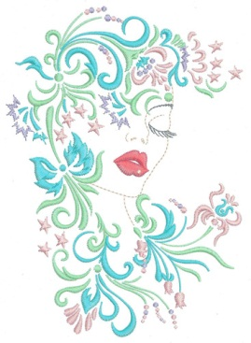
Kreations by Kara
Embroidery Designs For The Creative Mind

Kreations by Kara
http://www.kreationsbykara.com/
Thank you for purchasing our designs. We hope you enjoy them on whatever project you choose.

You will find design information each zipped file. Included will be a picture of the design, a color chart depicting the color, color name, type of thread brand used, dimensions and any other information pertinent to the design. If you have purchased a design or set that requires additional information such as assembly instructions, stitch out requirements or suggestions, these will also be included in the zipped file or within the .pdf depending on the instruction required for that particular design set.
In order to read the .pdf files you must have Adobe acrobat reader in version 9.0 or above. If you need an upgrade on Adobe, you may get one for no charge at this site: http://www.adobe.com/products/acrobat/readstep2.html

The original copyright of these files is owned with all rights reserved by the creator of the original files.
YOU HAVE PURCHASED A LICENSE TO USE THESE ELECTRONIC FILES.
When you purchase or download from Kreations by Kara, you are granted a single-user license of the files to create stitch outs from them.
The ownership of the design stitch files and related graphic files is retained by craftsperson that created them.
These digitized embroidery designs and graphics are protected under USA Federal Copyright Law & International Treaties.
The design and graphic files themselves, or any part thereof, cannot be sold, duplicated or shared in any way and are for use by the original purchaser/user only.
The user license covers the following uses:
The user may stitch out the designs on finished projects for personal use, gifts or resale by the original purchaser only. If the finished project items or stitch-outs are displayed for sale online or in a physical location (store), credit to the digitizer and link to www.kreationsbykara.com is required.
You may use the designs up to 25 each on items for resale at craft/sewing fairs or to sell in cottage industry.
This licensed does not cover mass production without additional permissions.
Transference of these files to any other person or group is strictly prohibited.
You may not lend, give or sell the files to anyone else EVER. You may not change, add to, delete parts of, or alter the files and then call them your own.
You cannot send them via email or by any other method to another embroiderer to be split or changed in any way.

Kreations by Kara may allow you to stitch out the designs in commercial use with a special license purchased from Kreations by Kara. To inquire about this license contact Kara via email.

For clarification or if you have any questions please contact me via email at: kreationsbykara@live.com

Once again thank you!
Kara

Kara Sutton
www.KreationsbyKara.com
kreationsbykara@live.com

